Fall | 2013

FALL#2022

SMI University



Name; Azhar-Uddin
Student ID; BSSE-20s-070
Program# BSSE(M)
Semester; #06
Section; SE (6A, B)
Course; Web Engineering

Course ID; SEN-204

Assignment#02

Submitted To: Sir Faheem Uz Zaman

<html>
<head>
<title>Software Engineering Job Application Form</title>
</head>
<body>

<form style="width: 35%; margin: auto" action="" method = 'post'>
<fieldset>

<legend>Application Form</legend>

<h1 style=text-align:center></h1>

<form>

<table>

<tr>

<td> Full Name:</td>
<td><input type="text" placeholder="Enter Your Name" name="name"></td>
</tr>
<tr>
<td>Email Id:</td>
<td><input type="email" placeholder="Enter Your Enmailm" name="email"></td>
</tr>
<tr>
<td>Gender:</td>
<td>
<input type="radio" name="gender" value="Male">Male
<input type="radio" name="gender" value="Female">Female
</td>
</tr>
<tr>
<td>Nationality:</td>
<td>
<select name="nationality">
<option>Select Option</option>
<option>Pakistani</option>
<option>Turkey</option>
<option>Saudia Arbia</option>
</select>
</td>
</tr>
<td>Skills:</td>
<td>
<input type="checkbox" name="skill[]" value="QA Engineer" />
<label for="QA Engineer"> QA Engineer</label>

<input type="checkbox" name="skill[]" value="Grapic Designer" />
<label for="Grapic Designer"> Grapic Designer</label>
<br>
<input type="checkbox" name="skill[]" value="Game Developer" />
<label for="Game Developer"> Game Developer</label>

<input type="checkbox" name="skill[]" value="Director of Engineering" />
<label for="Director of Engineering" > Director of Engineering</label>
</td>
</tr>
<tr>
<td>Post Applying For:</td>
<td>
<input type="radio" name="post" value="Trainee" style="margin-left: 4px ;"/>
<label for="Trainee">Trainee</label>

<input type="radio" name="post" value="Project-Manager" style="margin-left: 19px ;" />
<label for="Project-Manager">Project Manager</label>
<br>
<input type="radio" name="post" value="Software-Engineer" />
<label for="Software-Engineer">Software Engineer</label>

<input type="radio" name="post" value="Team-Leader " style="margin-left: 19px ;" />
<label for="Team-Leader">Team Leader</label>
</td>
</tr>
<tr>
<td>Upload Your Resume:</td>
<td>
<input type="file" id="myfile" name="myfile" multiple><br><br>
</td>
</tr>
<tr>
<td>Paste Your Resume:</td>
<td>
<textarea id="resume-paste" name="resume" rows="3" cols="20"> </textarea>
</td>
</tr>
<tr>
<td colspan="2">

<input type="checkbox" name="notify-via-email" id="notify-via-email" checked />
<label for="notify-via-email" >Notify me the status via Email</label >
<br>

<input type="checkbox" name="condition"id="condition" checked />
<label for="condition">I agree to terms and condition</label>

</td>
</tr>
<tr>
<td >
<button type="submit" name="submit">submit</button>
<button type="reset">Reset</button>
</td>
</tr>

</table>

</fieldset>

</form>

</body>

</html>

<?php
$connection = mysqli_connect('localhost','root','','assignment_02_db');
if(isset($_POST['submit'])){
$name = $_POST['name'];
$email = $_POST['email'];
$gender = $_POST['gender'];
$nationality = $_POST['nationality'];
$skill_1 = $_POST['skill'];
$post = $_POST['post'];
$resume = $_POST['resume'];

foreach($skill_1 as $skill_01)
{
$f_skill .= $skill_01.", ";
}
$request = "insert into assignment_02_form(name, email, gender, nationality, skill, post, resume) values ('$name','$email','$gender','$nationality','$f_skill','$post','$resume')";

$query = mysqli_query($connection, $request);

if($query){
?>
<script>
alert("Inserted successful.....");
</script>
<?php
}
else{
?>
<script>
alert("No Inserted");
</script>
<?php
}

}

?>

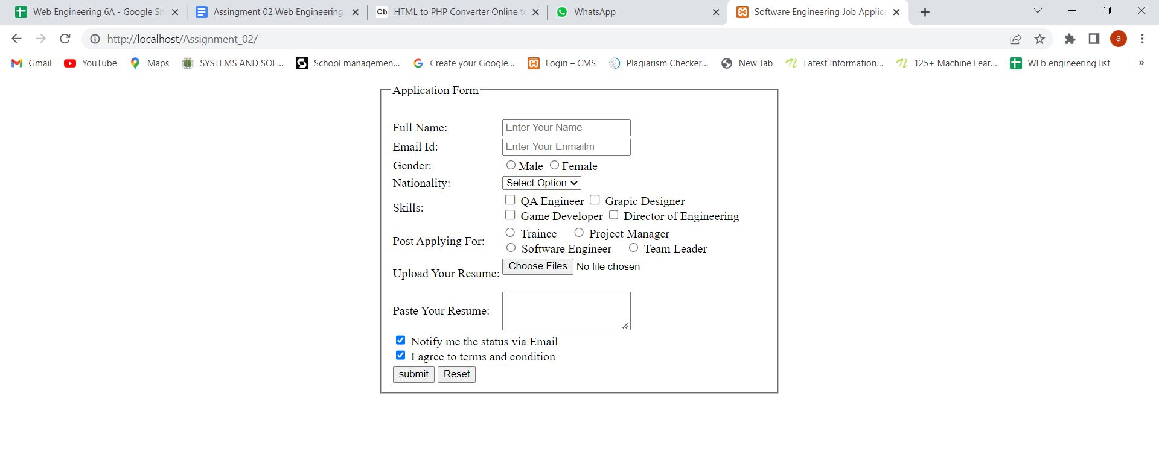

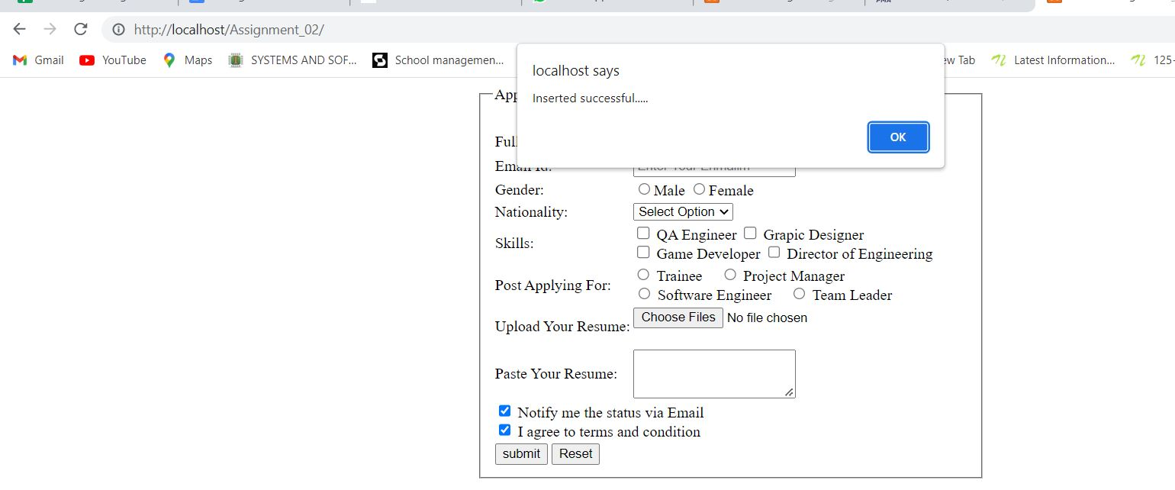

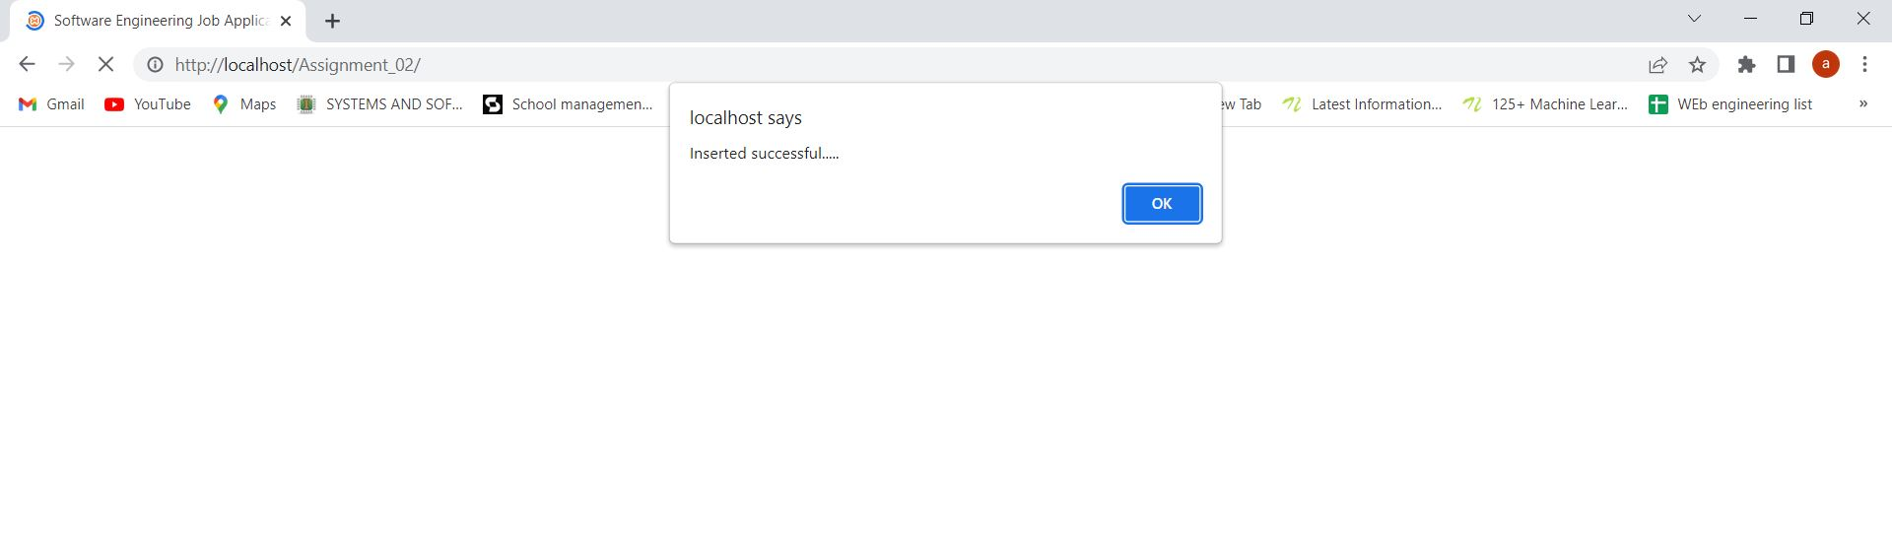

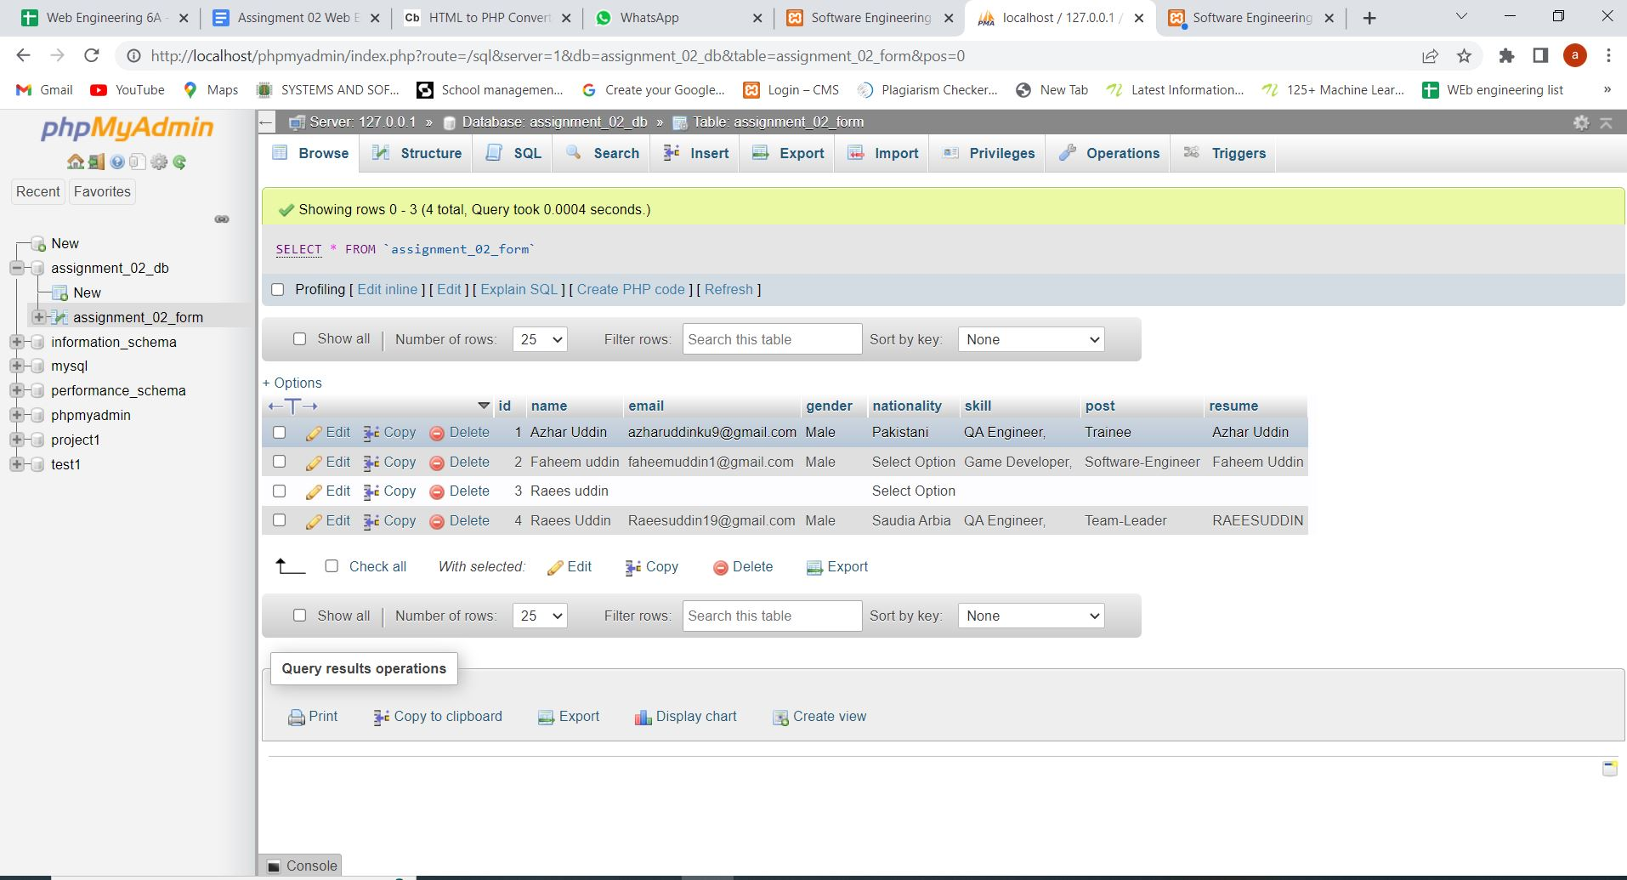

The End

